The template is a starting point for using with the Vivace export in order to print your Festival’s participation certificates. The template was created in Microsoft **Word** on a Mac and tested on a Brother laser printer. **You will need to make some additional adjustments due to the differences in computer OS and printers.** Please realize these instructions are for users with differing computer skills. Skip over the bits that you already know how to do. If you need more help, do an internet search to find a myriad of sites/videos with more detailed instructions.

1. **Print** these instructions for easier use.
2. **You must do your download and make adjustments to your spreadsheet before opening the template.**
3. Download the export and edit the spreadsheet for your festival.

* **To download the export file in Vivace**:
  + Go to Reports>Festival Tab>Select Festival Area & Festival
  + Select Report: scroll down to Certificate Export- Participation - Junior (or Senior)
  + Download report
  + 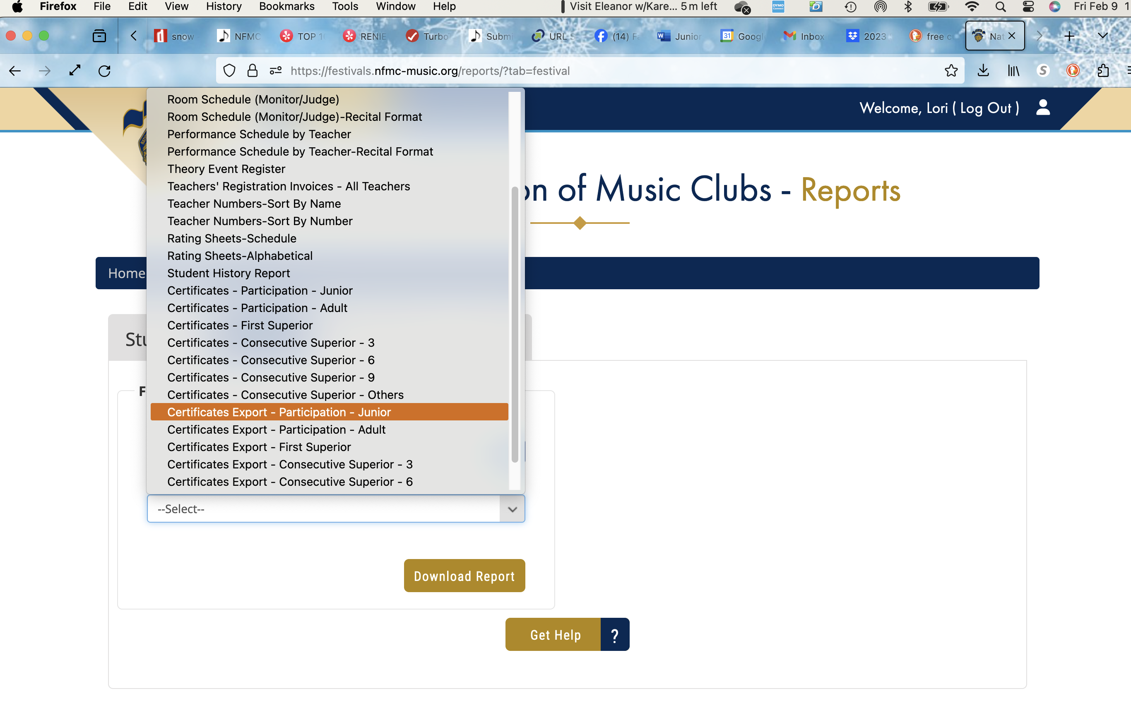Open downloaded certificate report.
* **Edit** the contents of the spreadsheet for a mail merge.
  + If you have l**ong event names** like American Patriotic and Folk Song or Lynn Freeman Olson Piano Solo, consider using abbreviations such as APFS or LFO Piano Solo. If you make no adjustments to the long event name, you will need to adjust the size of the font on the template in order for the name to fit.
  + **VIP!! If the name of your state is printed on your certificate, you can delete the “Held In” text.**  However, if there is a blank where the name of your state should be you will need to adjust the export for this. Currently, the exported value of the **“Held In” field** is the name of the Senior Club. You will need to **change this on your spreadsheet to the name of your state**. Edit the first cell of that column and drag down to fill the remainder.
  + Save your changes.

1. **Open the template**. You will be prompted to select the source document. Navigate to your downloaded file and select the certificate export.
2. From the ribbon, select **Mailings**.
3. 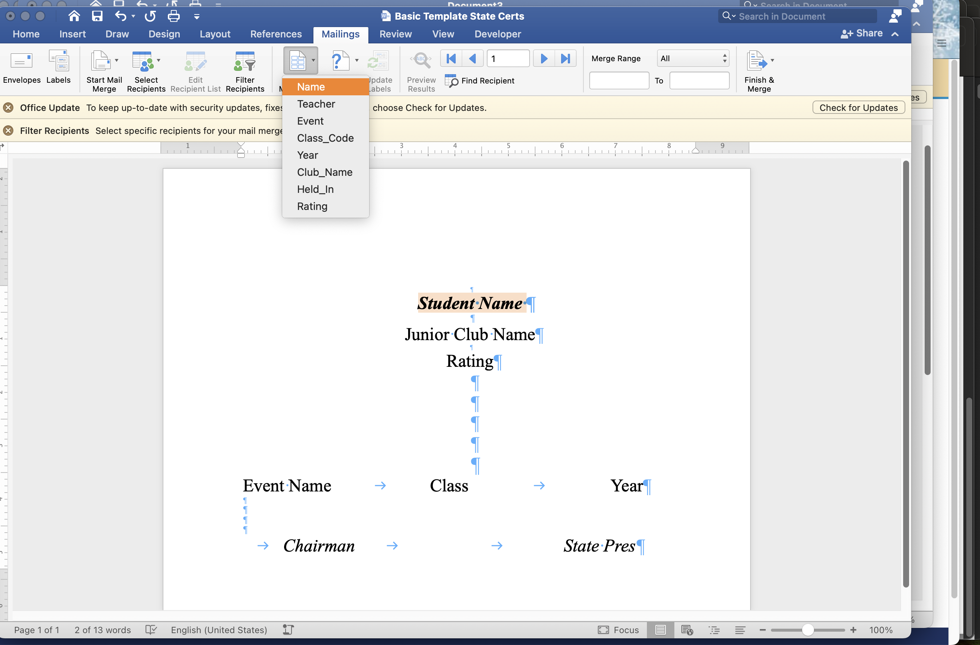Click **Preview Results** to check and see if the mail merge is complete. If successful, you will see the specific data for a student displayed. If not, deselect the Preview Results, highlight the text that is not correct, and select **Insert Merge Field.** Select the appropriate field.
   * **Signatures may be inserted** in place of the “Chair” and “State Pres” text. You will need picture files (JPEG, PNG) of the desired signatures.
     + From the menu at the top: Insert>Pictures>Picture from File, navigate to the signature file and select. Note: inserted picture may be extraordinarily large. Resize as needed. 😊 Drag signature file to the desired location.
     + Alternatively, **a script font can be used in place of a signature file.** Simply select the “Chair” or “State Pres” text and choose a different font. Adjust spacing as needed.
4. **Run a test print** on plain paper for one page only. Stack this page on top of a blank certificate and hold up to the light. How is the alignment? Make any alignment adjustments:
   * Tweaking is easier if you go to the Word Preferences and Turn ON All Non-Printing Characters.
   * Fonts change alignment. The template is created with Times New Roman font in various sizes/formats. Because there is not a common script font for both Mac and Windows OS, the names are in italicized font. Feel free to personalize your template with your desired fonts.
   * Correct any line alignments.
   * Correct any spacing issues within a line. Hint: reset the tabs.
   * Save and retest. Repeat as needed.
5. When all is adjusted to your satisfaction, save, complete the merge, and print.